Designing Document Management System

Kai/Katarina Godfrey

Professor: Katie Newton

Computer Science 106: Introduction to Linux

February 26, 2022

1. Download and install Recoll to Ubuntu. Open up your terminal command applications and type in “sudo apt-get install recoll”. In the image below, I have Recoll already installed but it shows the command at the very top.   
   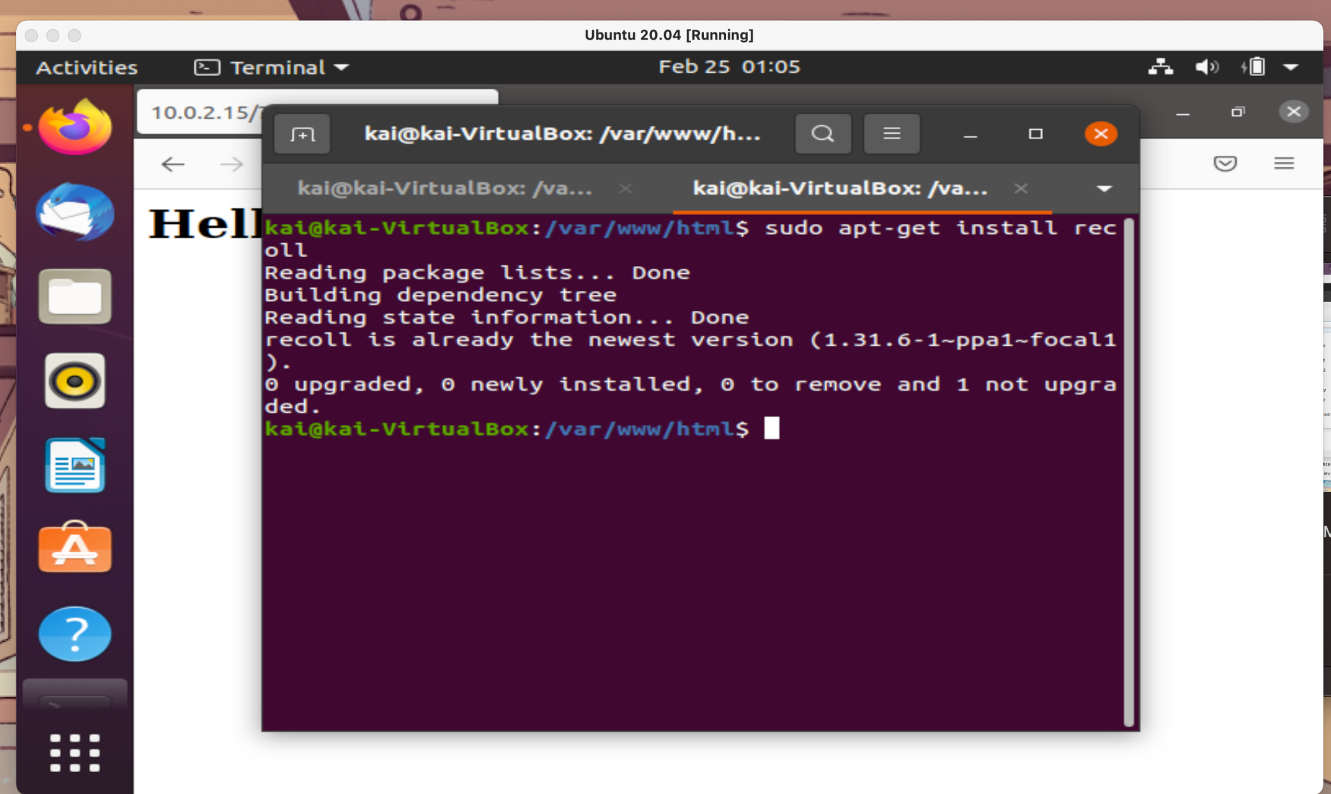
2. Recoll should be installed on Ubuntu as your program to index files. Recoll is a file management system that allows you to search for a file, an example would be to search for “.pdf” or “.bash”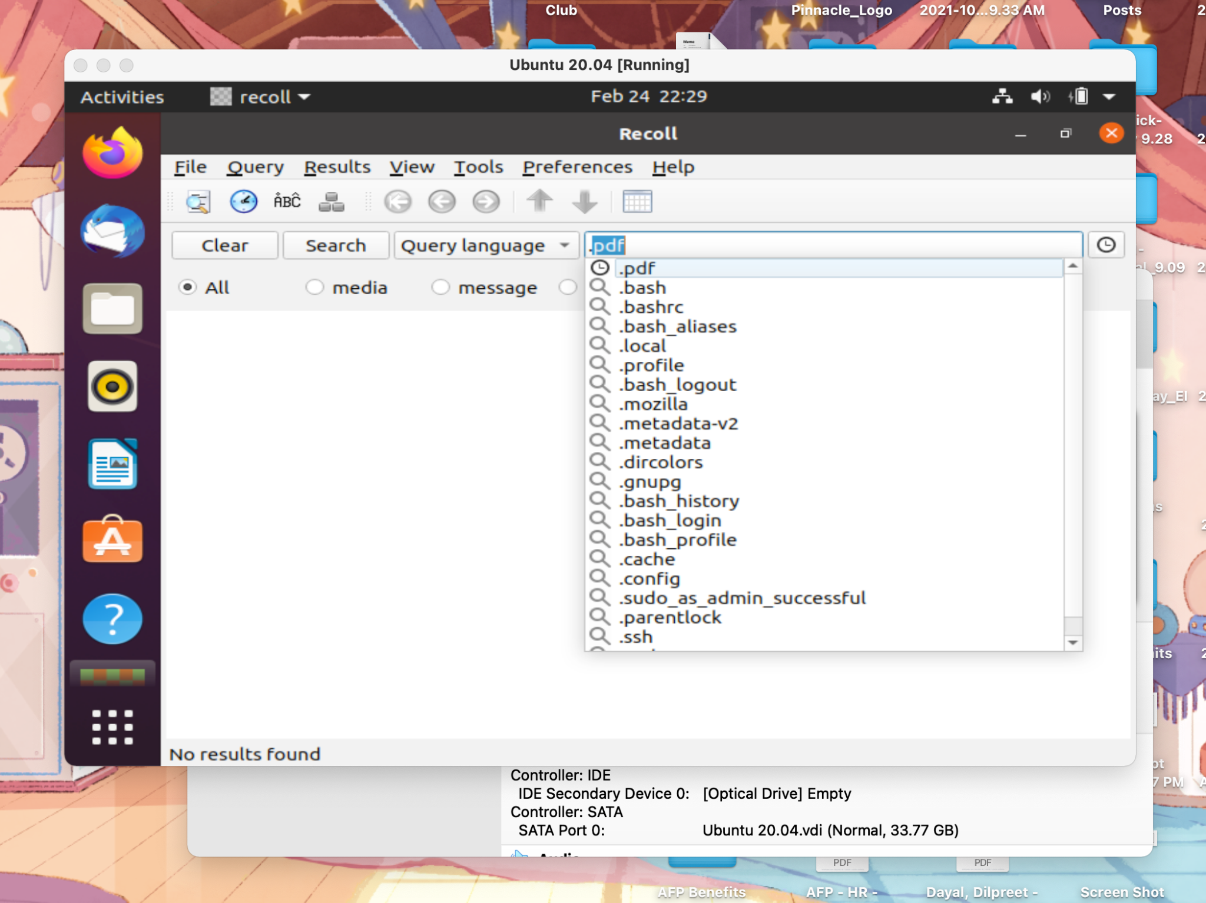
3. We are going to download Apache to set up a local web server. Open Terminal Command and enter “sudo apt-get install apache2”   
   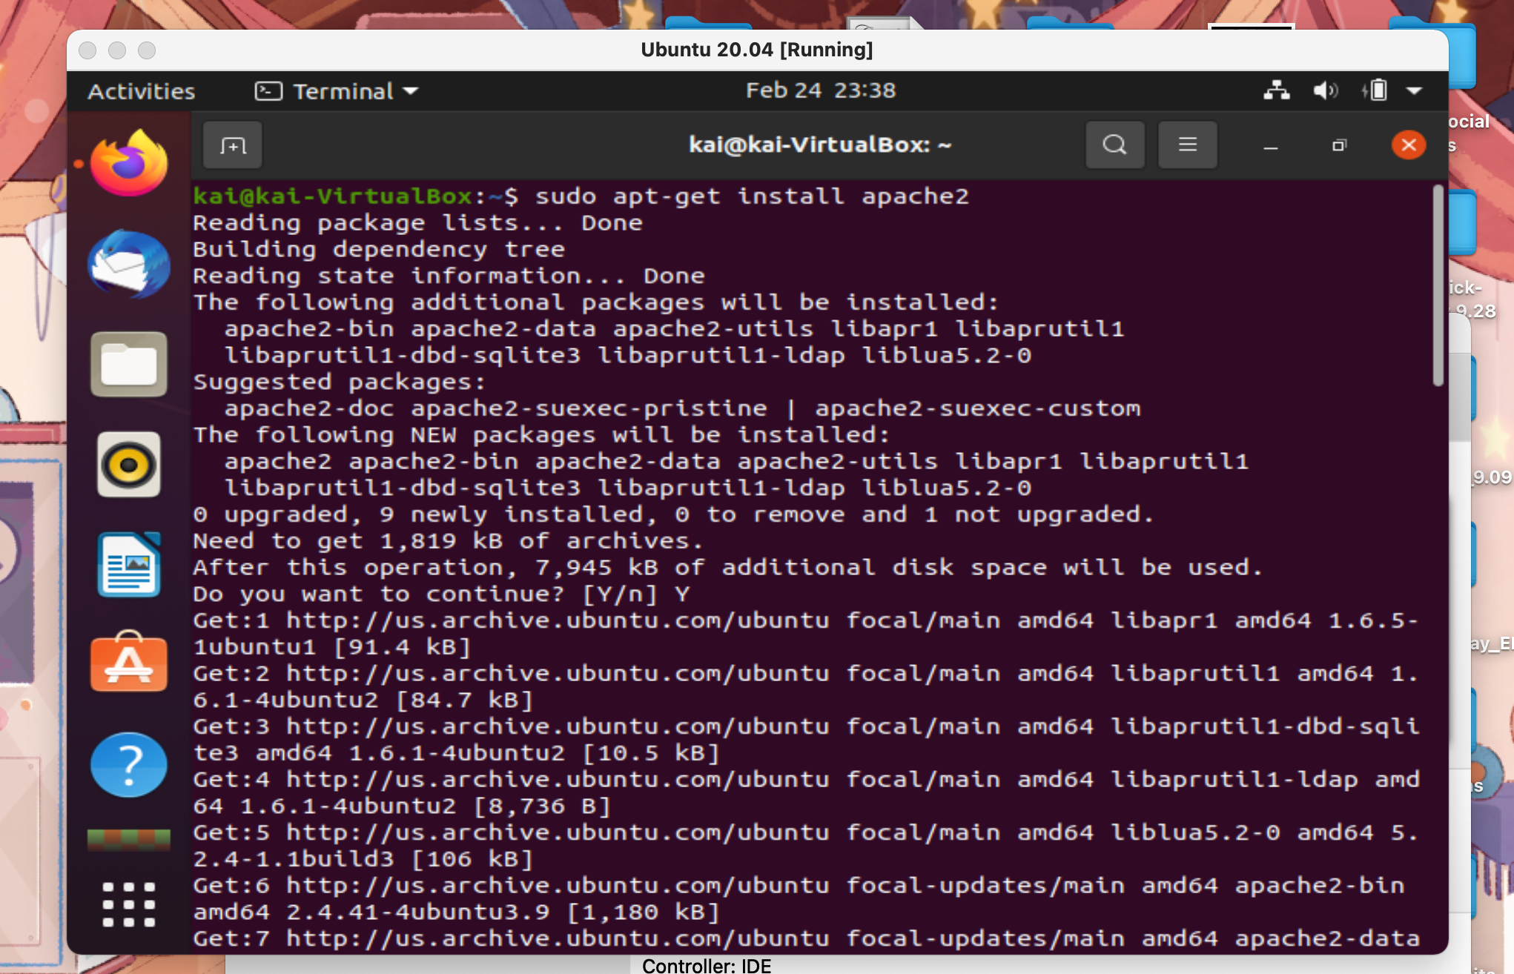
4. Open your web browser and type in “localhost”. This confirms that you have Apache2 downloaded on your device. It should say “It Works!”  
   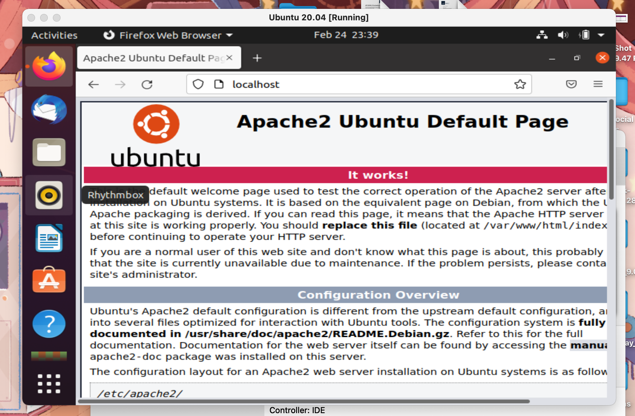
5. Type in terminal command “Ifconfig”. I highlighted in white my IP net for the numbers (10.0.2.15) we are using to paste in your web browser.   
   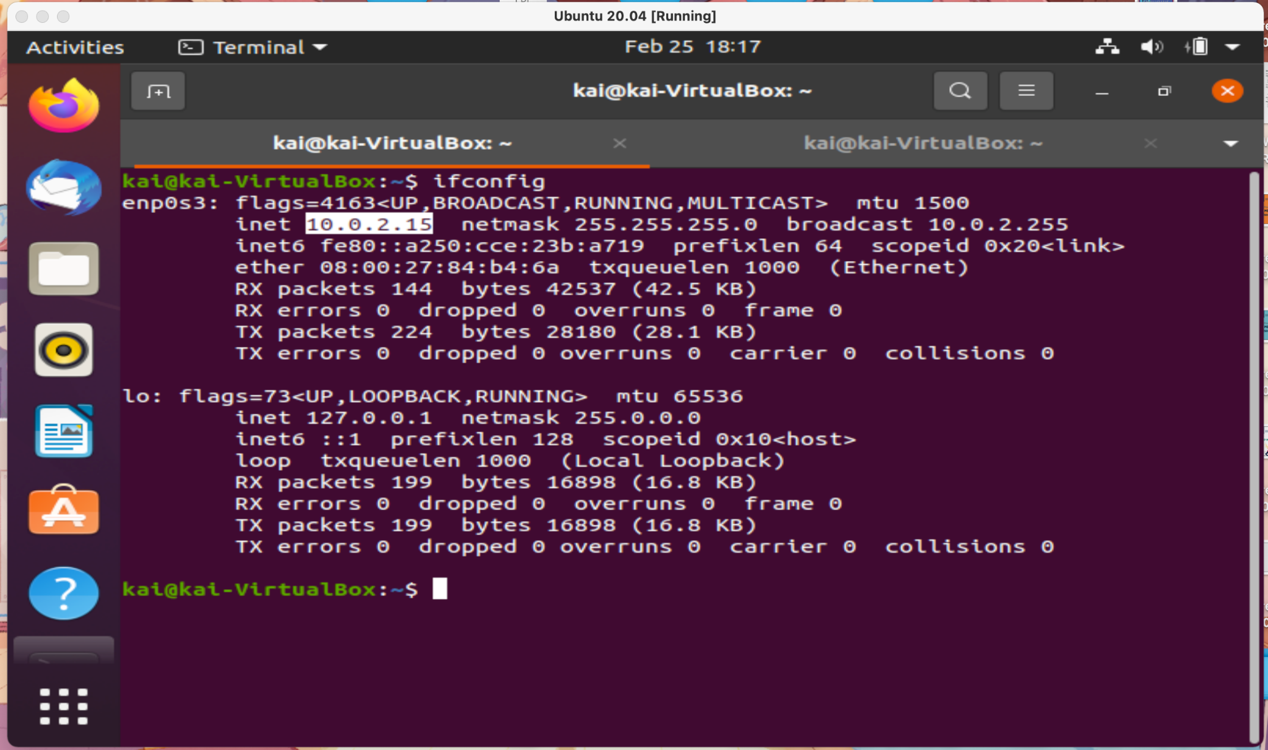
6. I already made my local server, but I typed in my IP net and it showed my local web server in which I used HTML to type “Hello World!”.   
   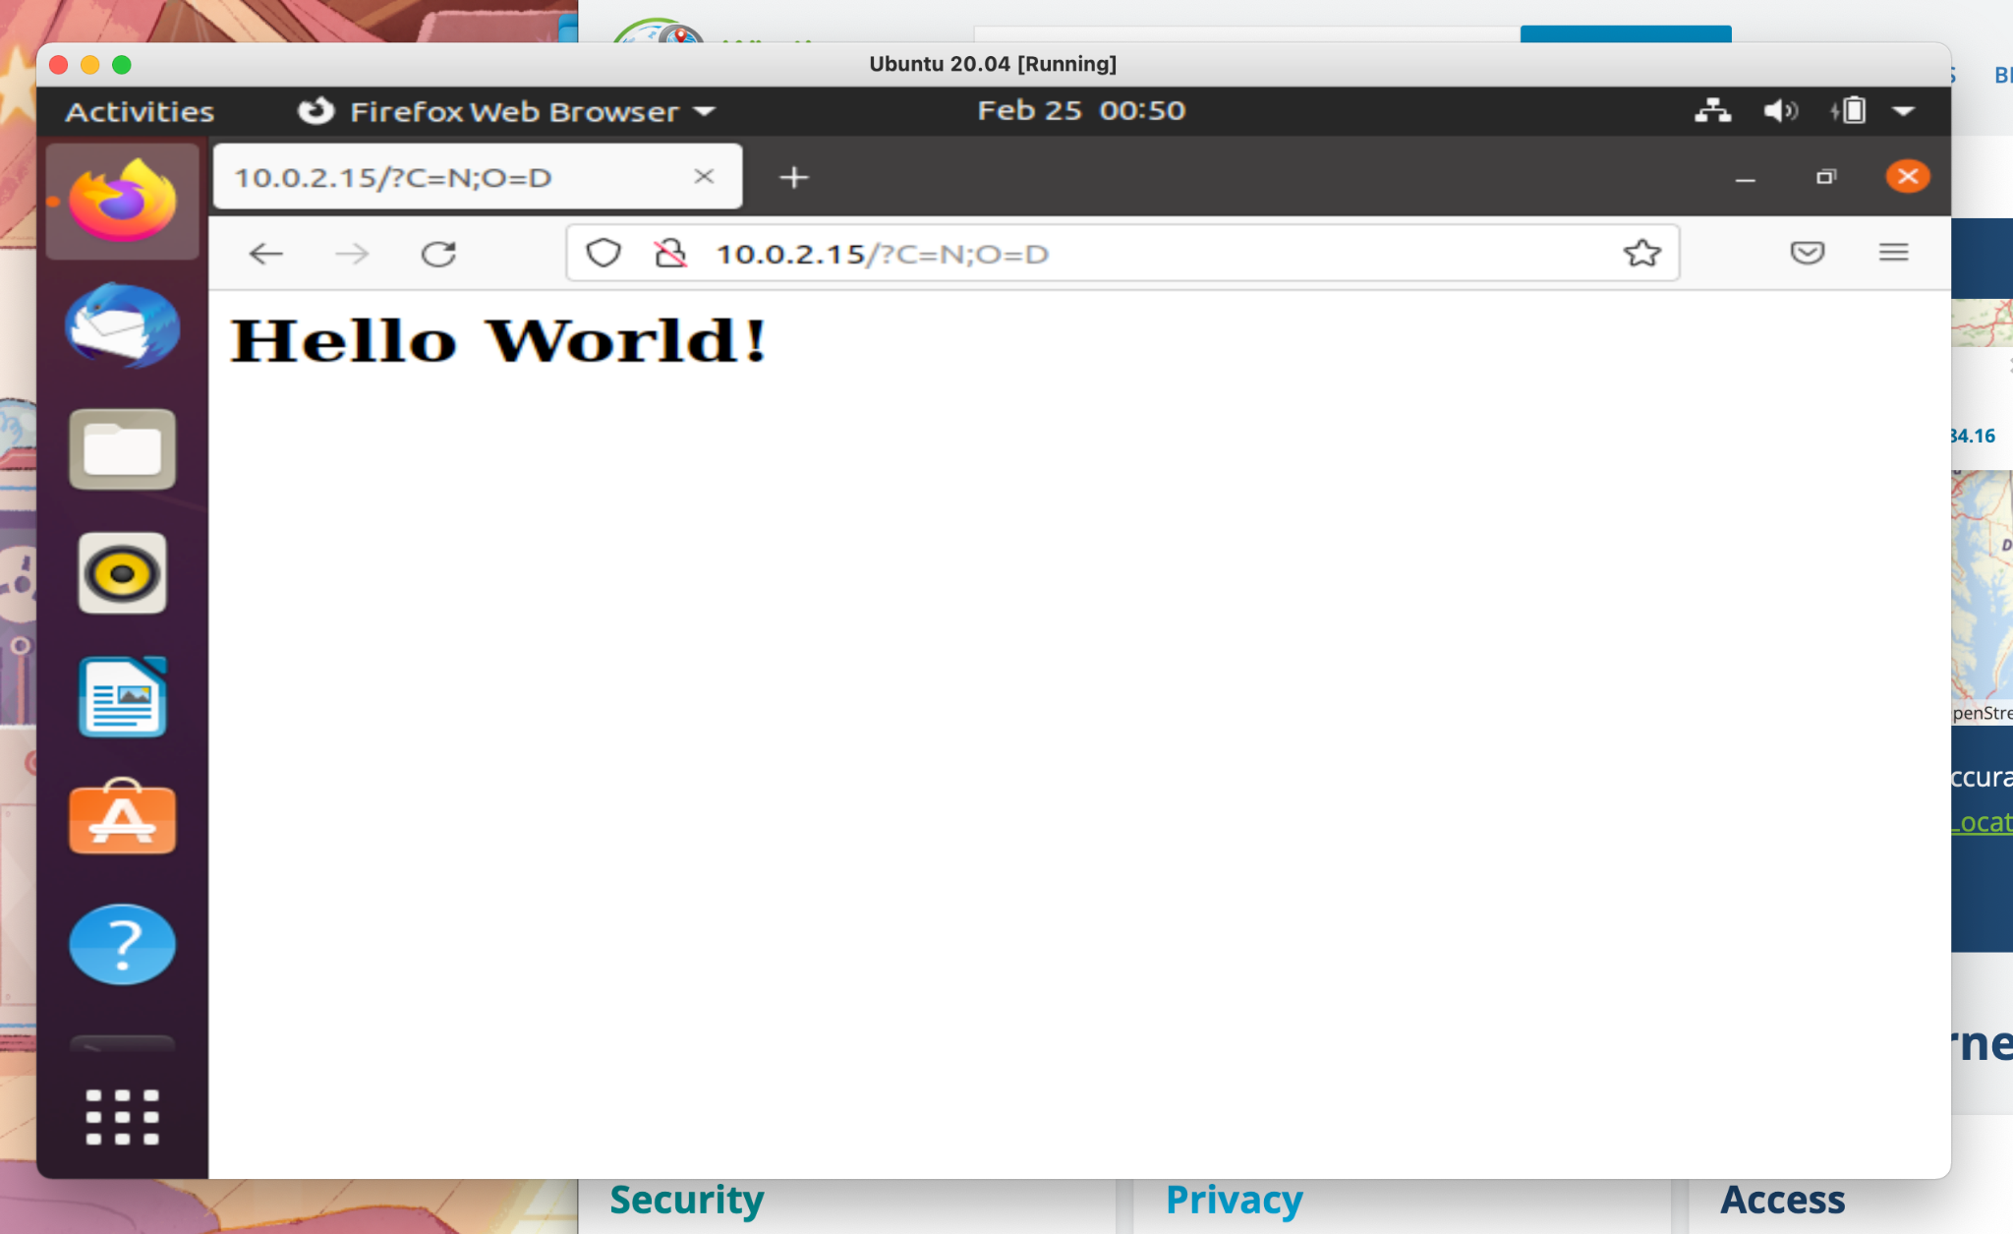

1. I typed in my terminal command “sudo nano /var/www/html/index.html”. It will ask for your admin password if you have one.   
   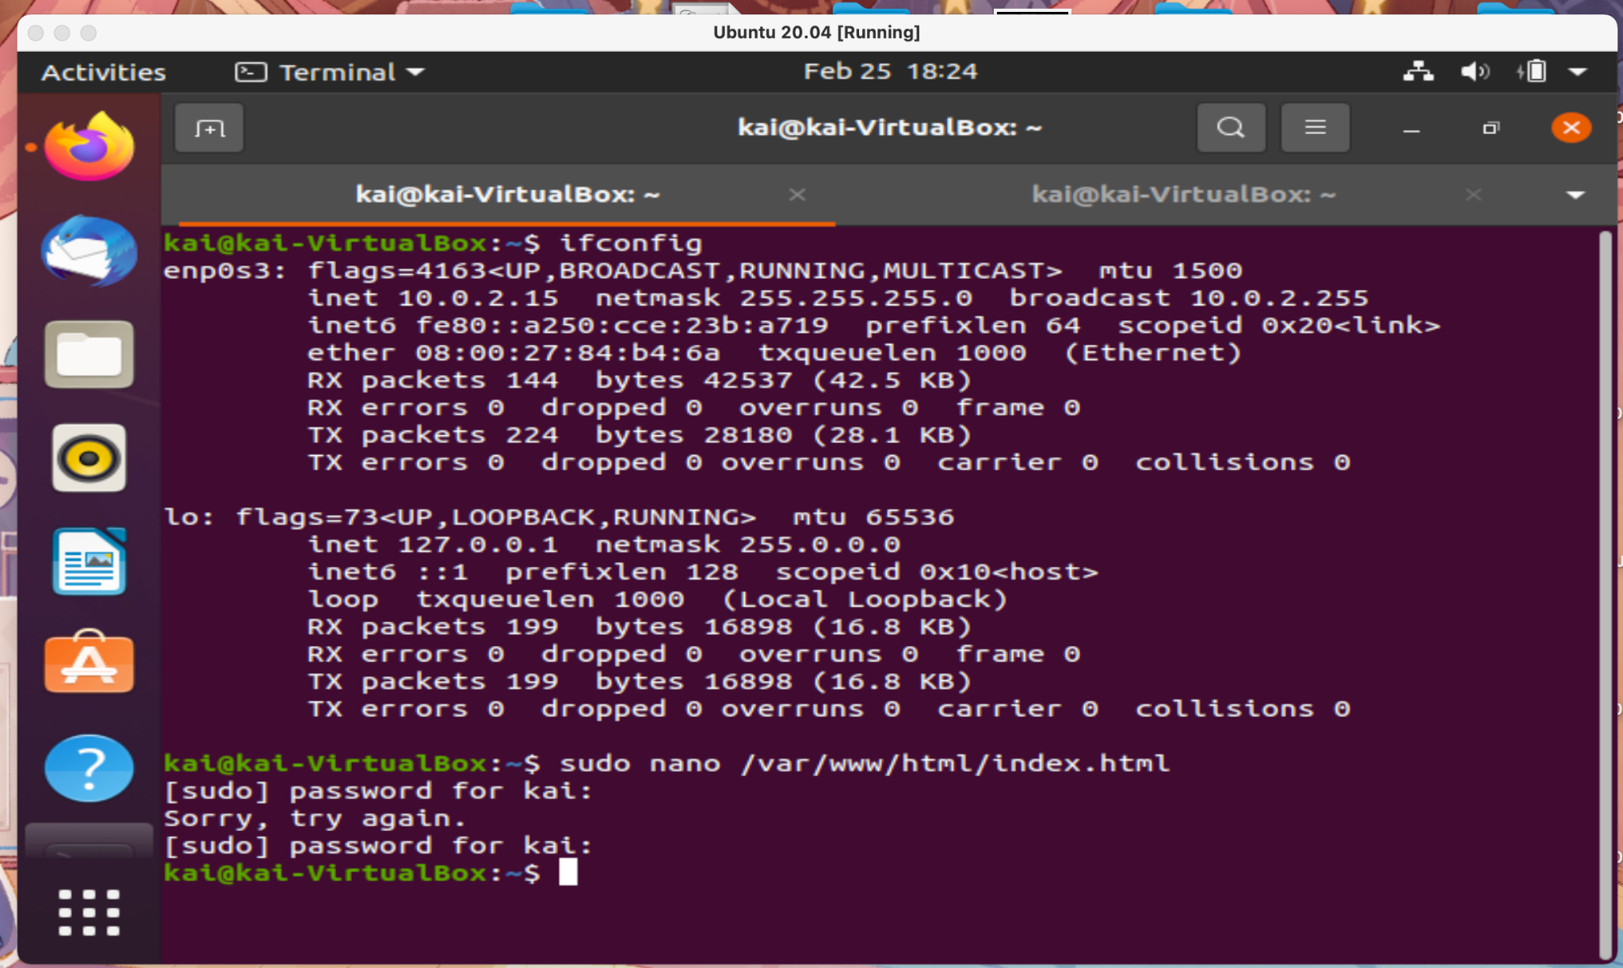
2. After you type in that commend then it shows this image. I put in html code for what I wanted on my local site. I click on Control + X.   
   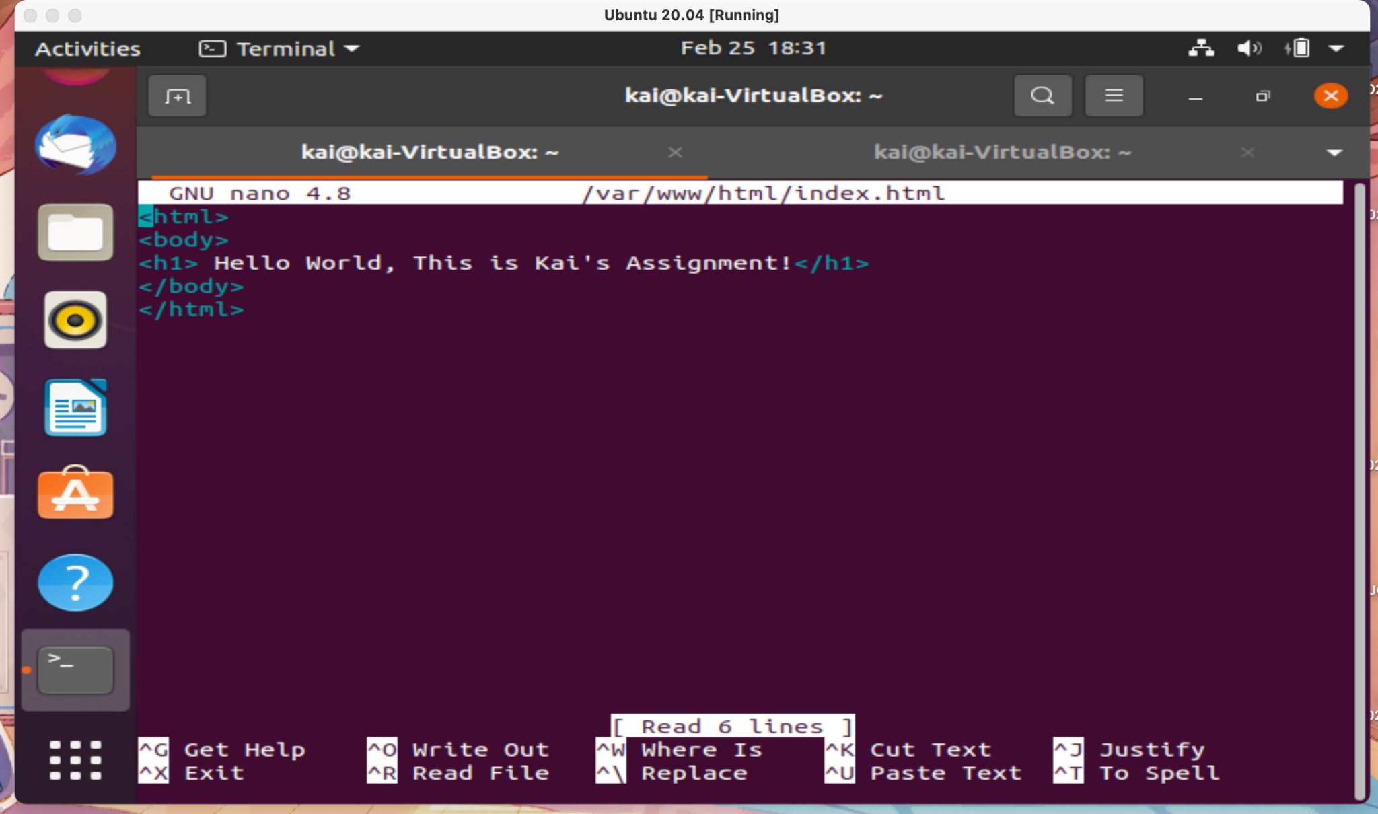
3. The next step is to put my IP net address in my web browser from before using “10.0.2.15”. In the Screenshot below you can see my html code showing up on my local web server.   
   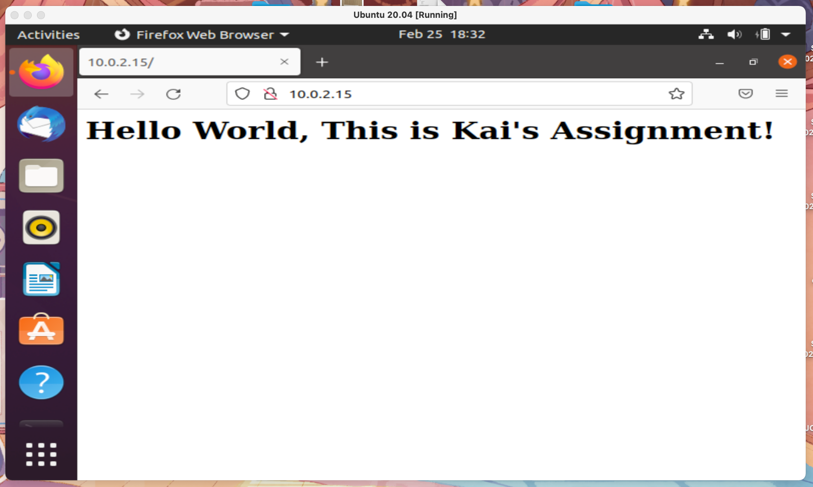
4. We are going to download a popular Web user interface program called cockpit. Cockpit is a graphic interface for servers on your local web server. Open up terminal and type “sudo apt install cockpit -y”   
   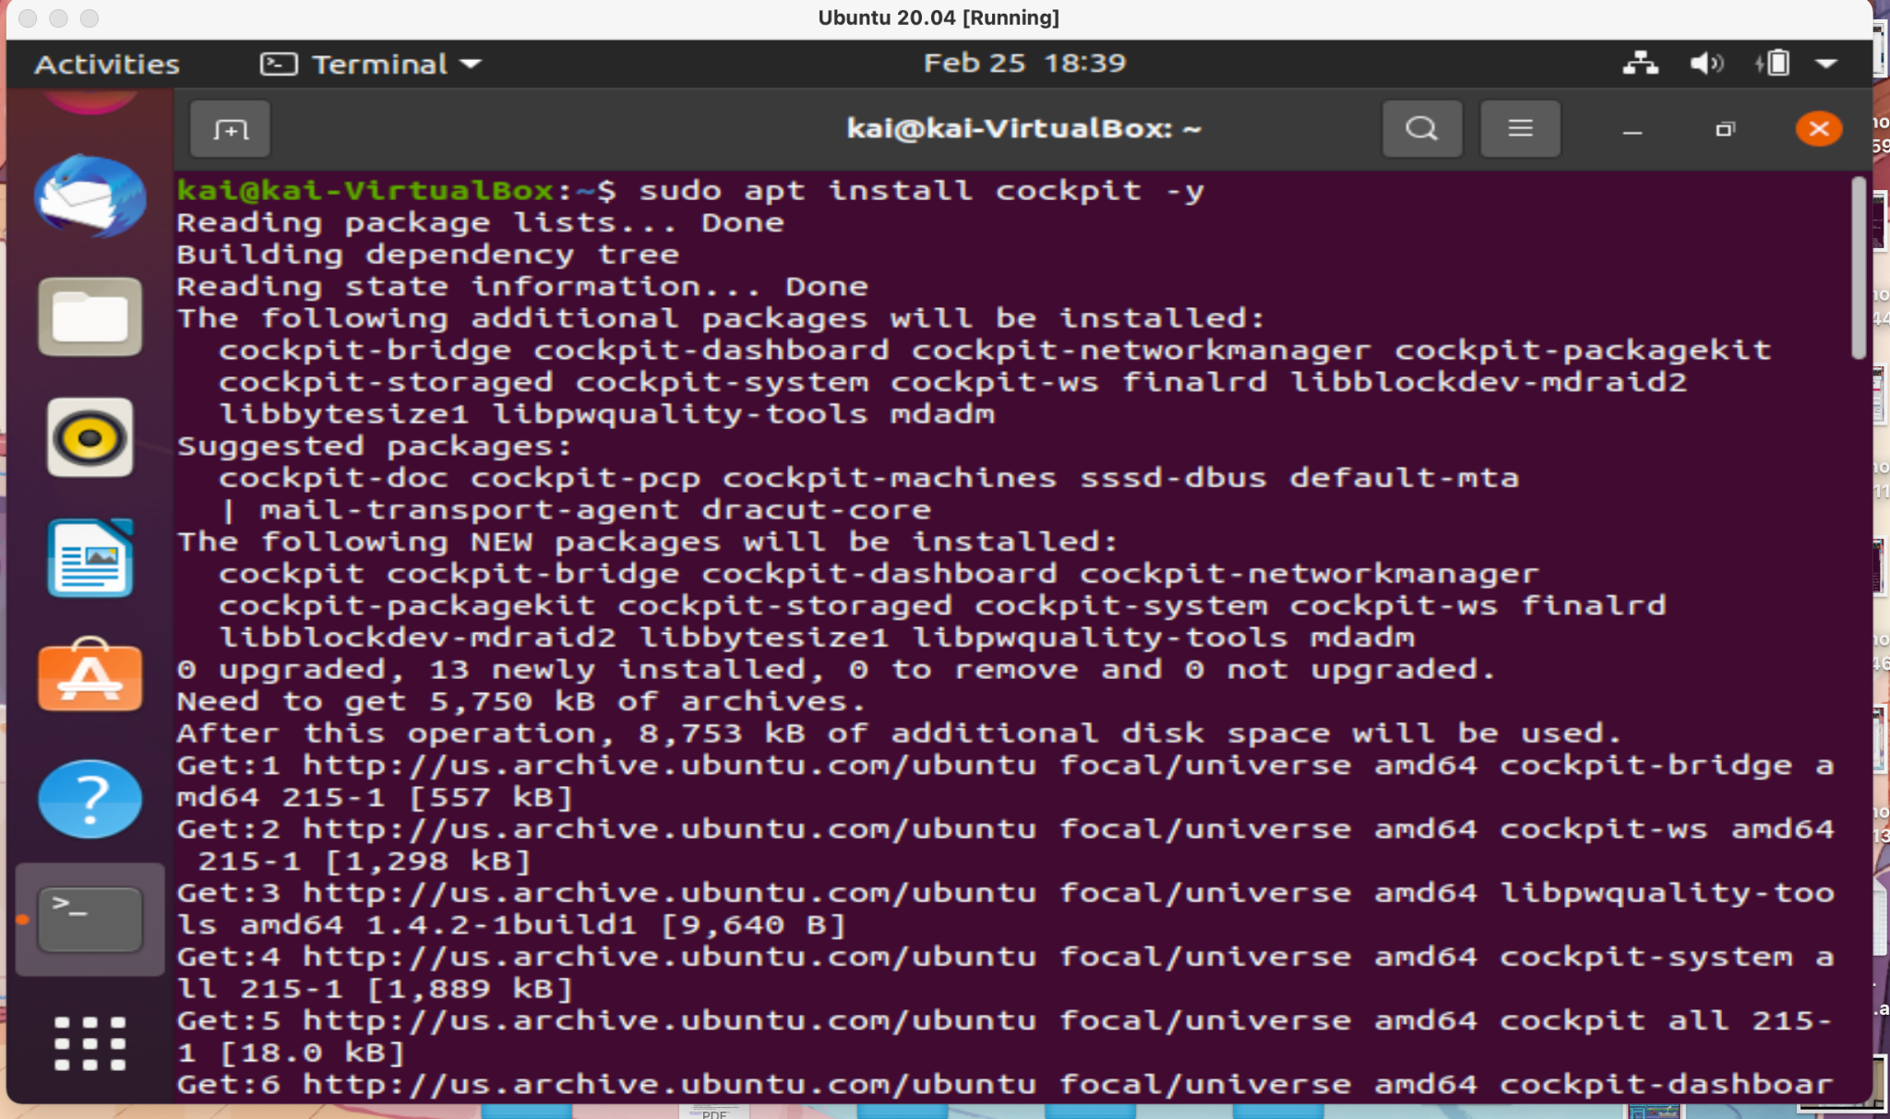
5. This is the progress bar in green showing the install.   
   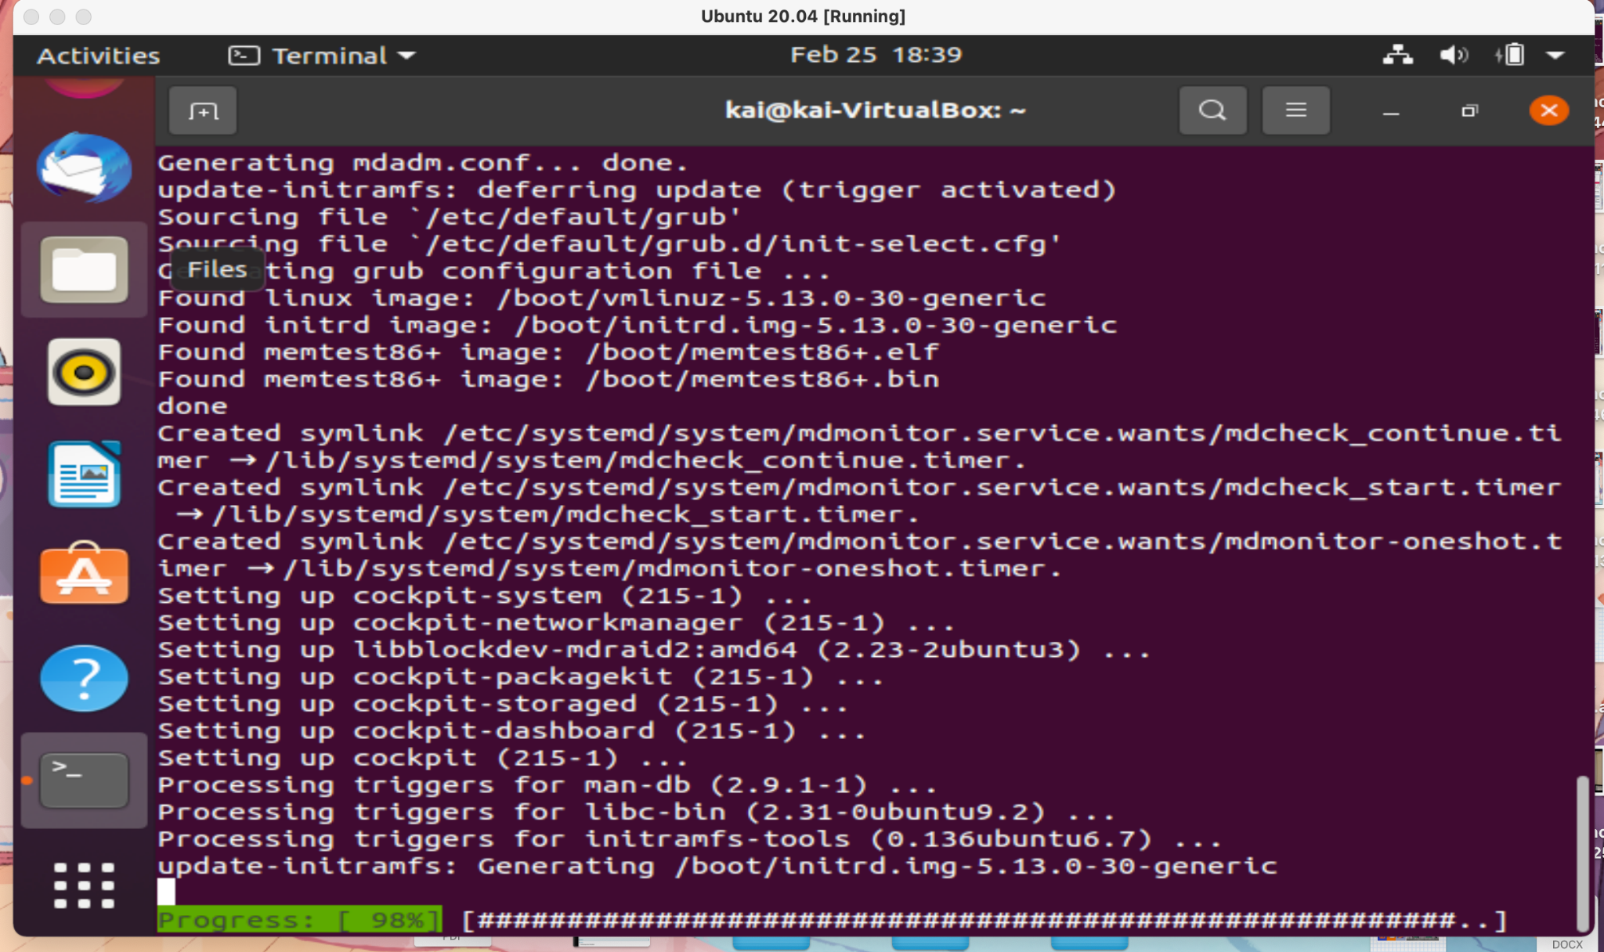
6. Type in the Terminal Command “sudo systemctl status cockpit” to show that it's up and running. In the screenshot below is showing it’s active and running.  
   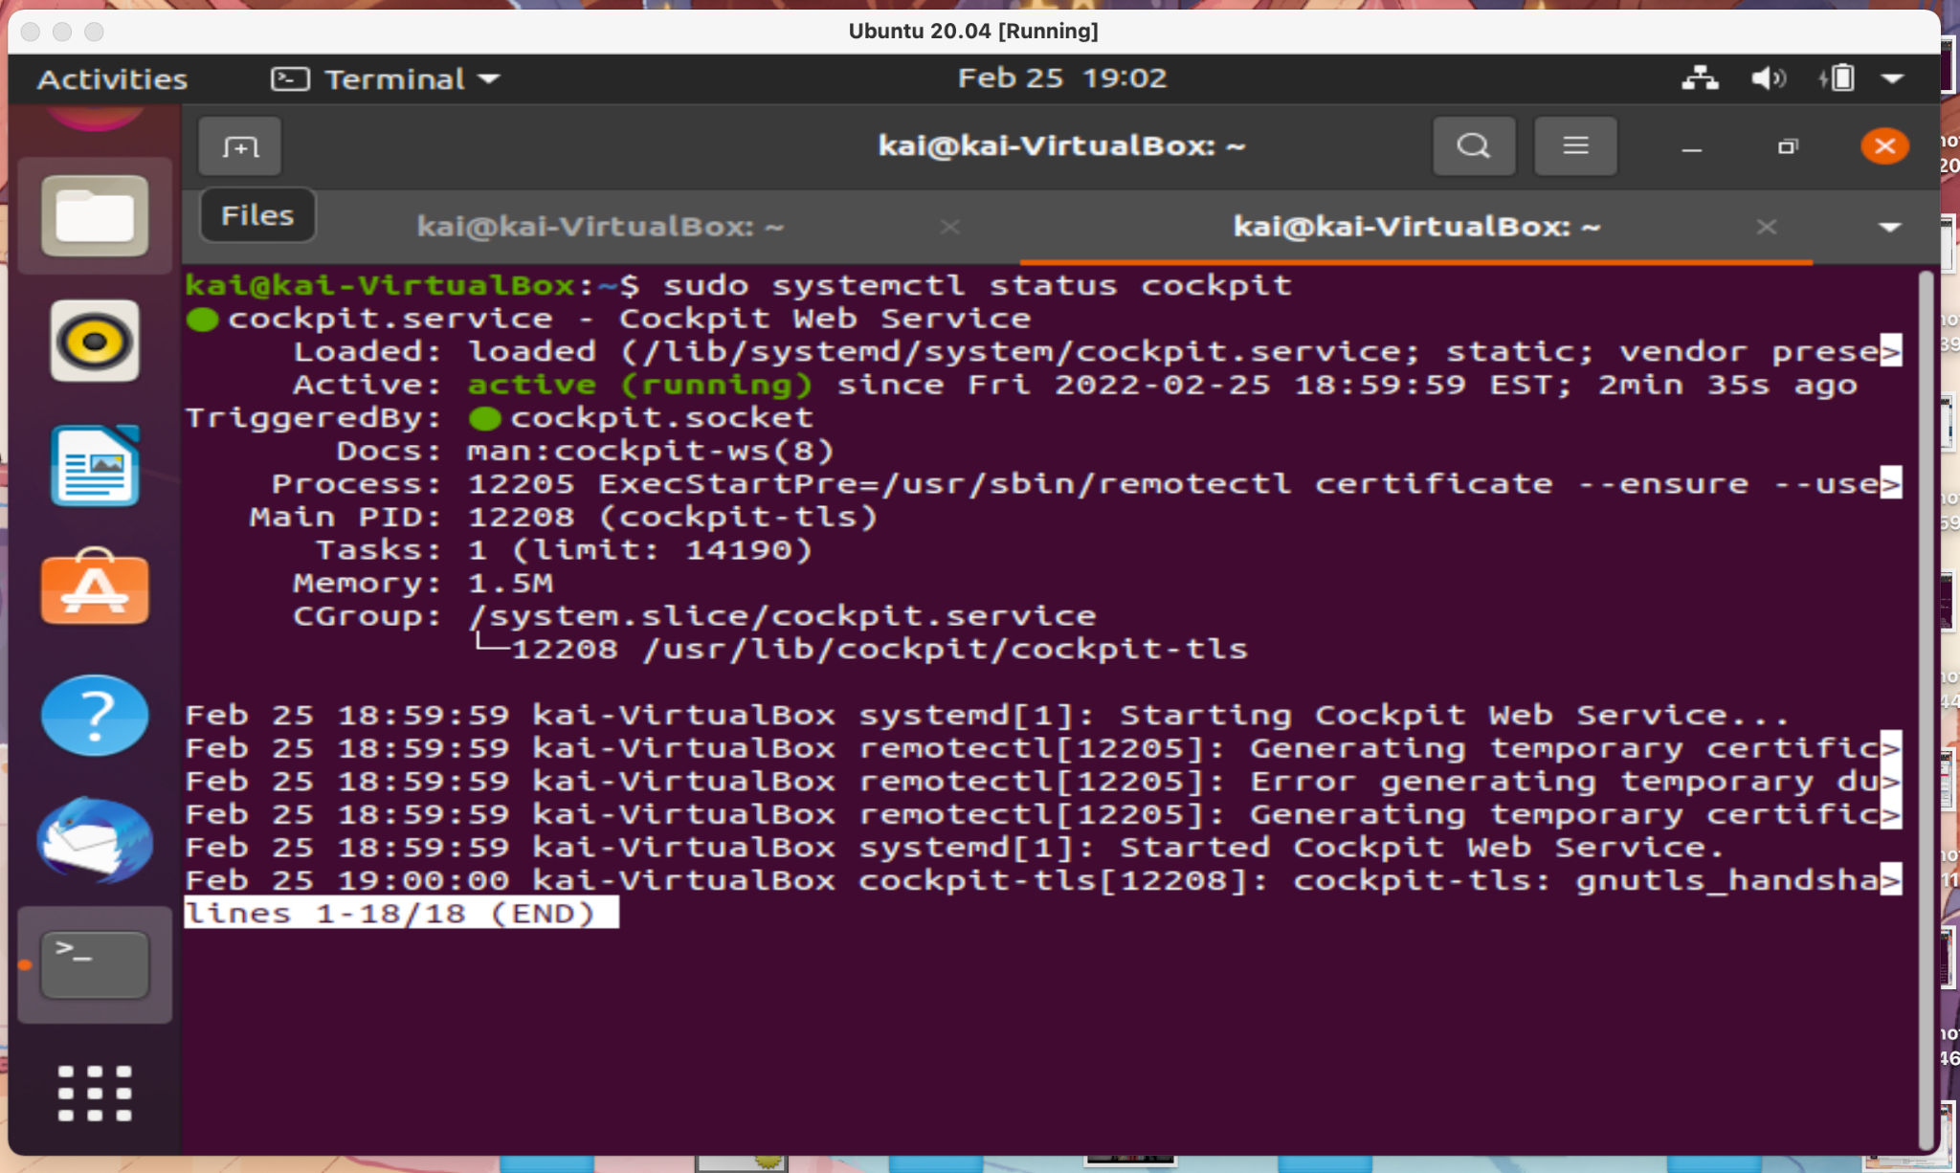

1. Type in your IP net and add “:9090” at the end which is “10.0.2.15:9090” it will say the connection is not private but just click in advance and continue. It will show ubuntu log in.   
   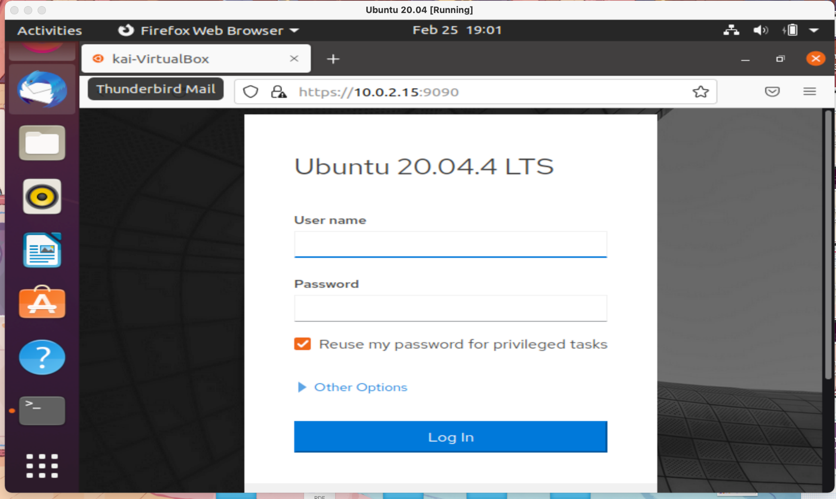
2. Log into your admin account that you use to log into your linux log in. You can see your usage, health, dashboard, configuration and system information.   
   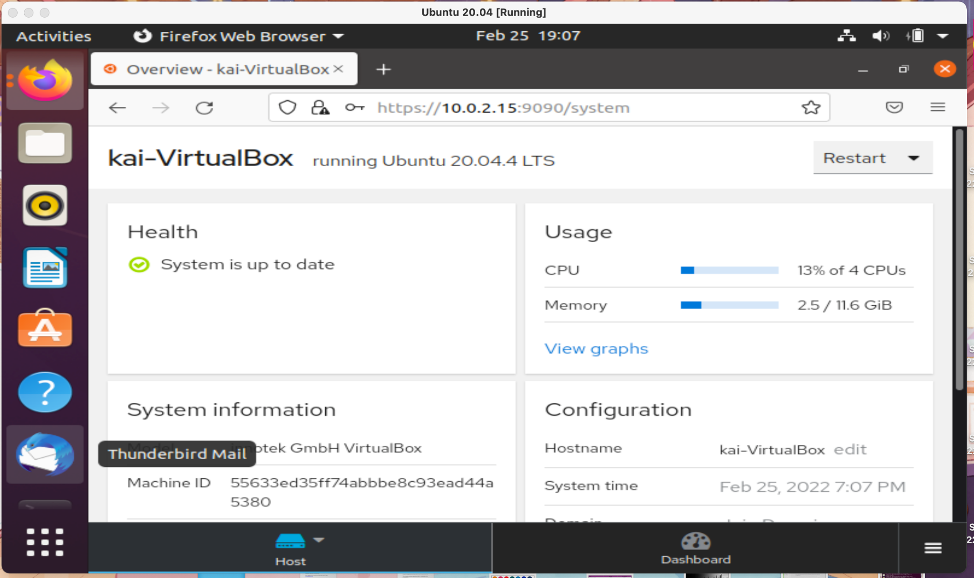
3. Cockpit has a search bar but just not for Ubuntu so I can’t search anything, but everything is there. I have a screenshot of searching in Recoll which is a UI program. Click on File and then Update Index. In the second screenshot you can see I searched “.pdf” before.   
   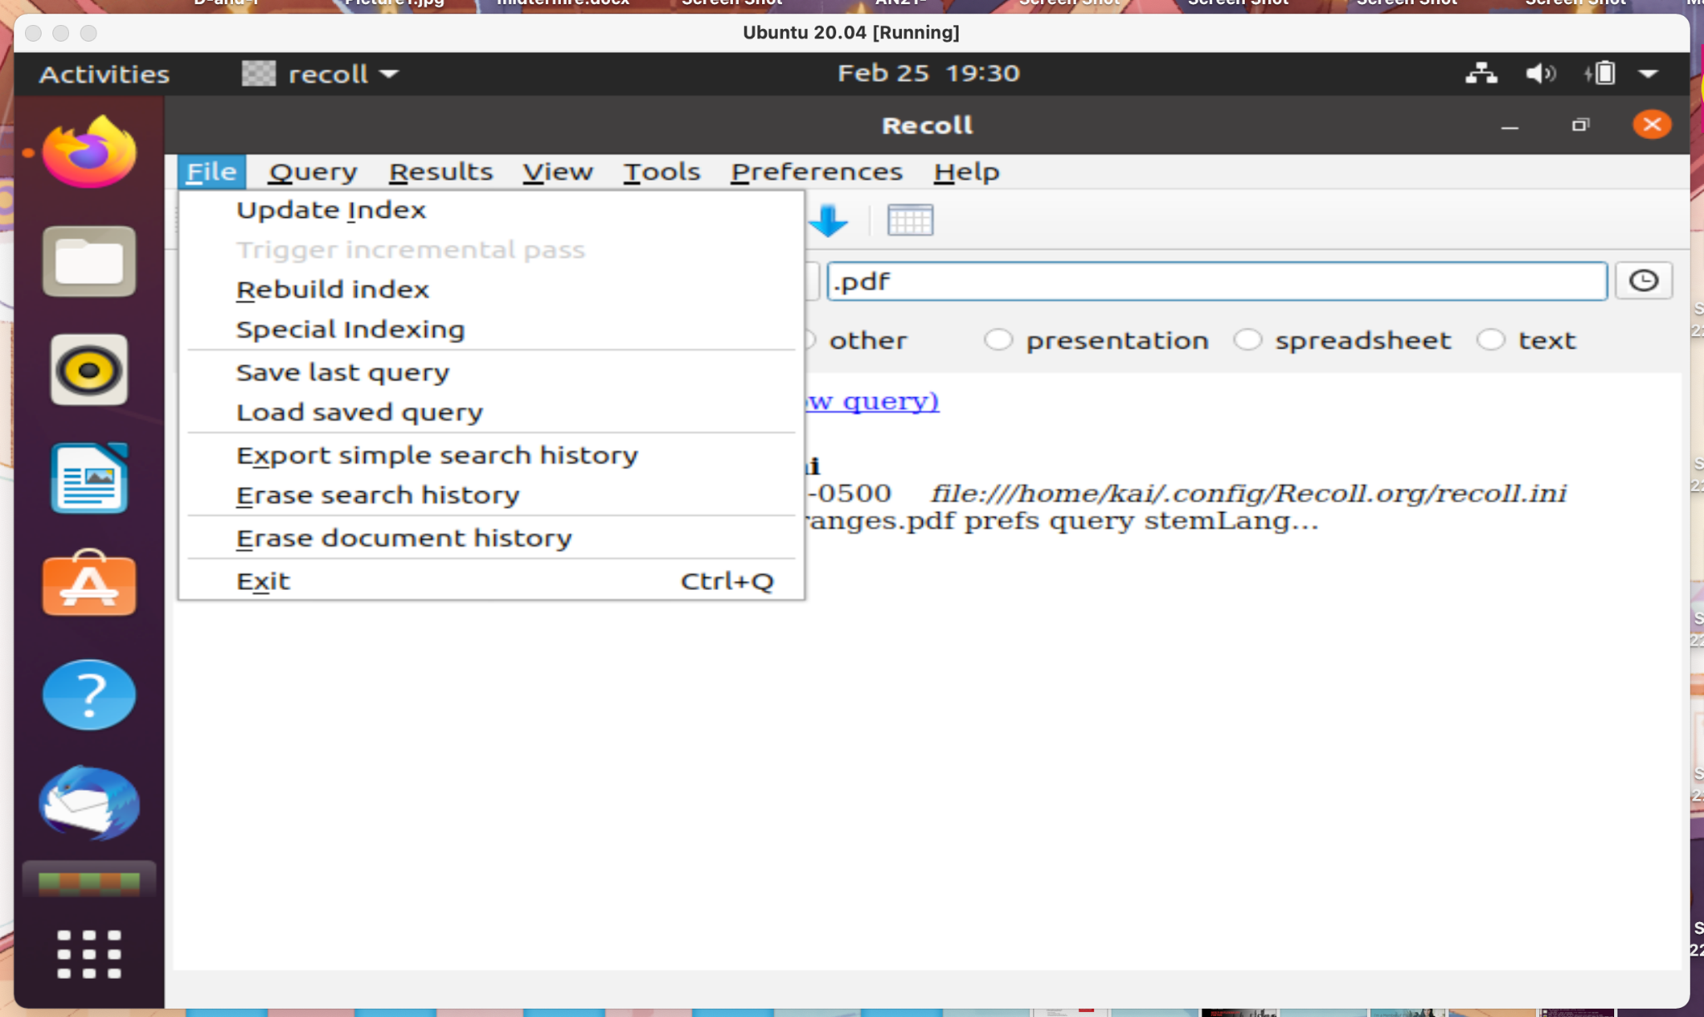  
     
   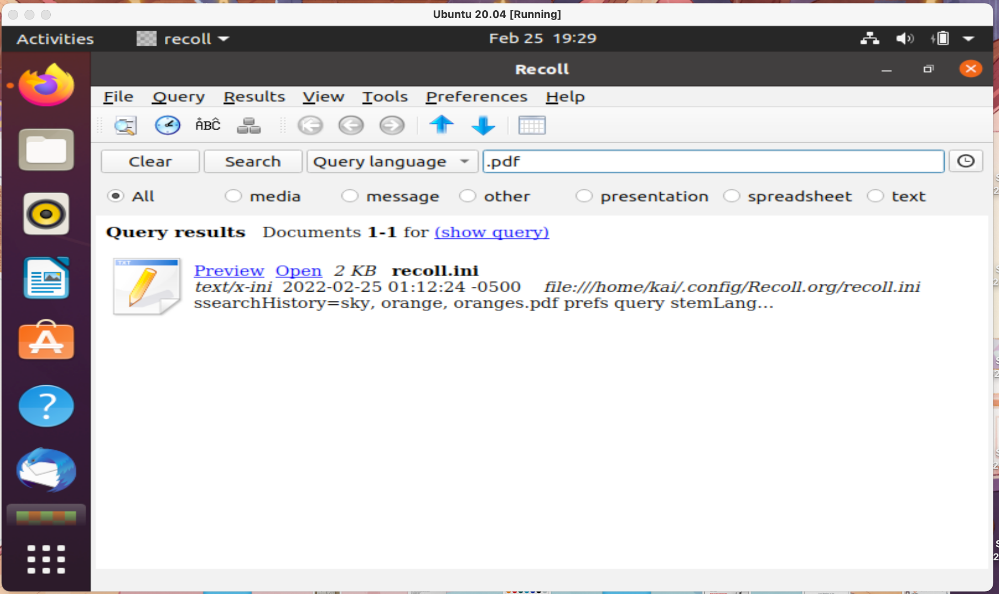

Bibliography

“Cockpit Project.” Cockpit Project, February 16, 2022. https://cockpit-project.org/.

“How to Install Recoll in Ubuntu 18.04.” How to install Recoll in Ubuntu 18.04. Accessed February 26, 2022. https://www.howtoinstall.me/ubuntu/18-04/recoll/.

Padilla, Aden. “Install and Configure Apache.” Ubuntu. Accessed February 26, 2022. https://ubuntu.com/tutorials/install-and-configure-apache#1-overview.